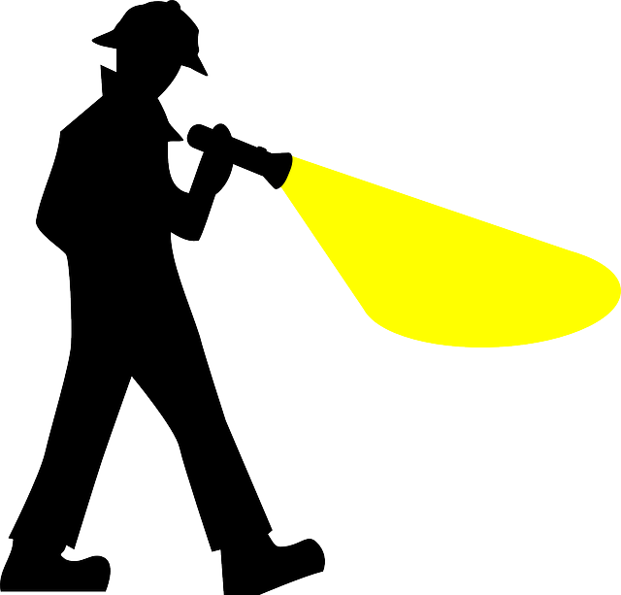
Rock
Cycle Hunt

Question | Answer
What is a rock?
What is the
rock cycle?
Why do
rocks melt?
What is crystallization?
What is an
igneous rock?
What is an intrusive igneous rock?
What is an extrusive igneous rock?
What is weathering?
What is erosion?
What is deposition?
What is sedimentation?
What is compaction?
What is cementation?
What is a sedimentary rock?
What is metamorphism?
What is a metamorphic rock?

